COGNIFYZ TECHNOLOGIES
DATA SCIENCE INTERNSHIP – LEVEL 3 REPORT
Restaurant Rating Prediction, Customer Preference Analysis, and Data Visualization Using Python

Submitted By
Yarrabothula Jayanth

Internship Domain
Data Science

Submitted To
Cognifyz Technologies
"Where Data Meets Intelligence"

Tools & Technologies Used
- Python
- Pandas
- NumPy
- Matplotlib
- Scikit-learn
- Visual Studio Code (VS Code)

Submission Date
July 2026

TABLE OF CONTENTS
- Introduction
- Objective
- Dataset Description
- Tools and Technologies Used
- Task 1 – Predictive Modeling
- Task 2 – Customer Preference Analysis
- Task 3 – Data Visualization
- Overall Results and Discussion
- Conclusion

1. Introduction
This report presents the work completed for Level 3 of the Cognifyz Technologies Data Science Internship. The focus of this level was to apply machine learning techniques, analyze customer preferences, and create meaningful visualizations from the restaurant dataset.
The project involved building regression models to predict restaurant ratings, examining customer preferences based on cuisines and votes, and visualizing important patterns within the dataset. These activities provided practical exposure to predictive analytics and data visualization using Python.

2. Objective
The primary objective of this project is to apply machine learning algorithms and visualization techniques to extract meaningful insights from restaurant data.
The specific objectives are:
- To build regression models for predicting restaurant ratings.
- To compare the performance of multiple machine learning algorithms.
- To analyze customer preferences based on cuisines and voting patterns.
- To identify highly rated cuisines.
- To visualize important relationships within the dataset.
- To strengthen practical knowledge of predictive analytics and data visualization.

3. Dataset Description
The restaurant dataset contains 9,551 records and 21 attributes describing restaurants, customer ratings, pricing information, cuisines, geographical details, and customer votes.
Important features used in this level include:
Feature | Description
Aggregate Rating | Target variable used for prediction
Average Cost for Two | Restaurant pricing
Price Range | Cost category
Votes | Customer engagement
Cuisines | Food categories
City | Restaurant location

4. Tools and Technologies Used
Tool | Purpose
Python | Programming language
Pandas | Data preprocessing
NumPy | Numerical operations
Matplotlib | Data visualization
Scikit-learn | Machine learning
VS Code | Development environment
Why These Tools?
These technologies provide efficient methods for data preprocessing, machine learning, visualization, and model evaluation. They are widely adopted in the data science industry and are suitable for solving predictive analytics problems.

5. Task 1 – Predictive Modeling
5.1 Objective
The objective of this task was to develop regression models capable of predicting restaurant aggregate ratings using selected numerical features.

5.2 Methodology
The following steps were performed:
- Loaded the dataset.
- Selected relevant numerical features.
- Split the dataset into training and testing sets.
- Built Linear Regression, Decision Tree Regression, and Random Forest Regression models.
- Evaluated model performance using R² Score, Mean Absolute Error (MAE), and Mean Squared Error (MSE).
- Compared the performance of all models.

5.3 Code Implementation
Insert important code snippets only:
- Dataset loading
- Feature selection
- Train-test split
- Model training
- Performance evaluation

5.4 Results
Insert screenshots: 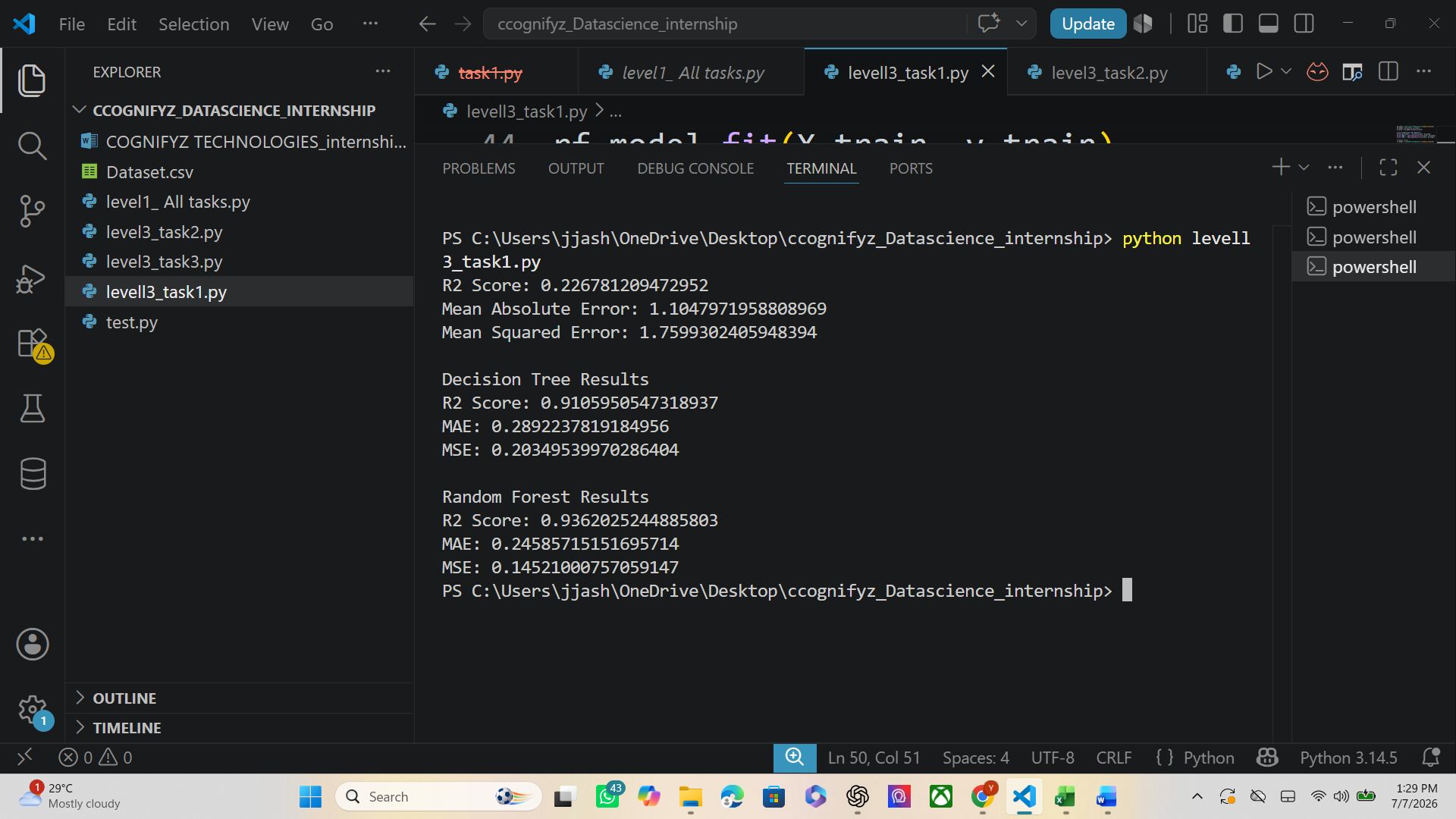
Figure 2: Model Comparison
- Model | - R² Score | - MAE | - MSE
- Linear Regression | - 0.2268 | - 1.1048 | - 1.7599
- Decision Tree | - 0.9106 | - 0.2892 | - 0.2035
- Random Forest | - 0.9362 | - 0.2459 | - 0.1452

5.5 Observations
Three regression algorithms were evaluated to predict restaurant ratings.
Among all models, Random Forest Regression achieved the highest prediction accuracy with the best R² Score and the lowest prediction errors.
The comparison demonstrated that ensemble learning methods produced more reliable predictions than a simple linear regression model for this dataset.

6. Task 2 – Customer Preference Analysis
6.1 Objective
To understand customer preferences by analyzing cuisines, customer votes, and restaurant ratings.

6.2 Methodology
The following analyses were performed:
- Calculated average ratings for different cuisines.
- Determined the cuisines receiving the highest number of customer votes.
- Identified the most frequently occurring cuisines.
- Compared customer preferences using summary statistics.

6.3 Code Implementation
Insert important code snippets:
- Grouping by cuisines
- Vote analysis
- Average rating calculation

6.4 Results
Insert screenshots:
- Figure : Average Rating by Cuisine
- 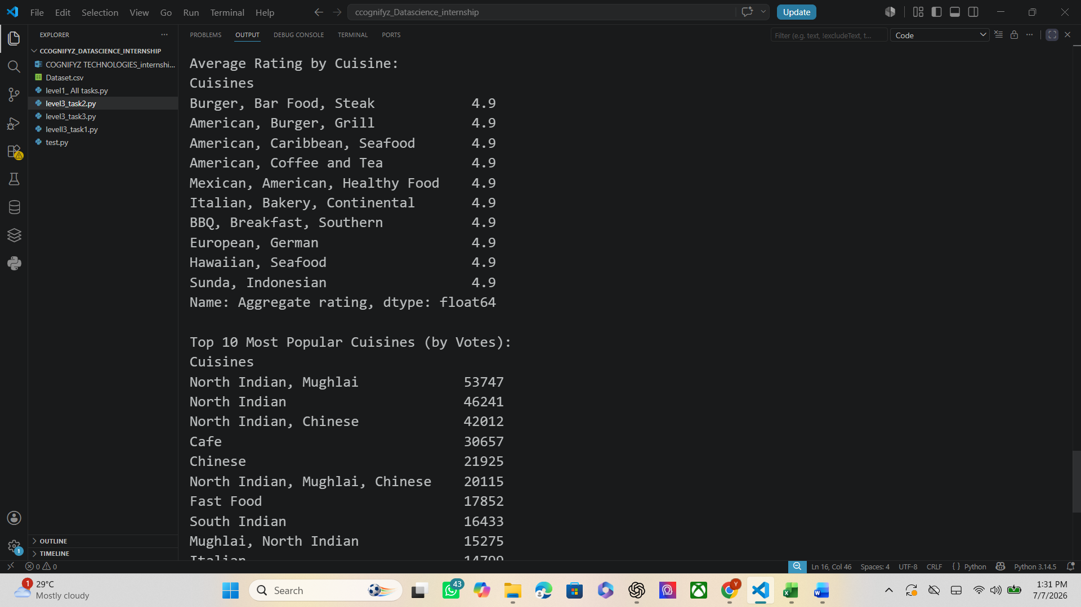
- Figure : Most Popular Cuisines Based on Votes
- 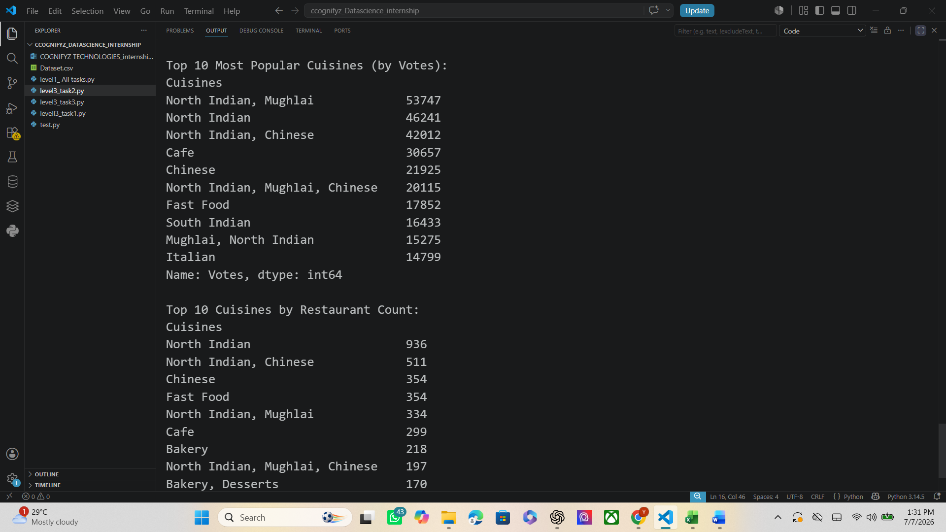
- Figure: Top Cuisines by Restaurant Count
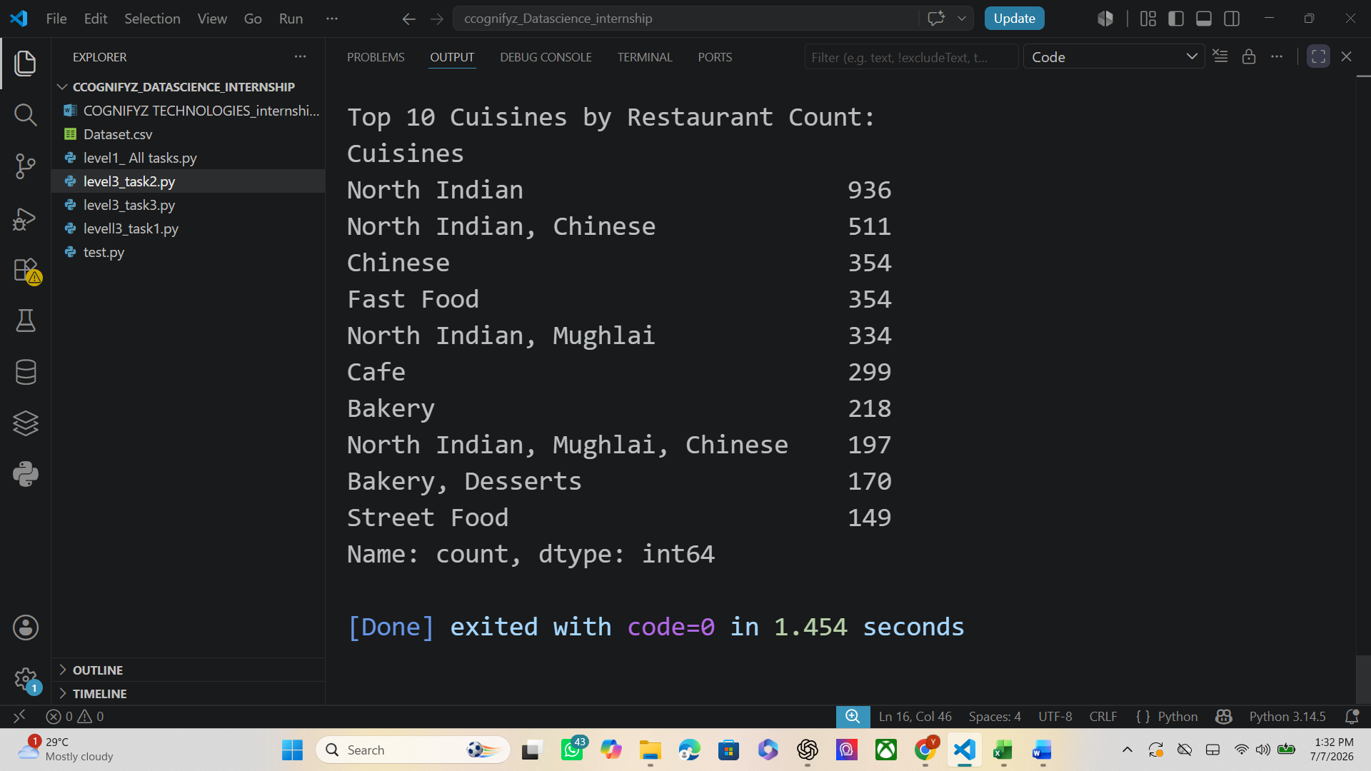

6.5 Observations
The analysis indicated that customer preferences vary significantly across cuisines.
Certain cuisines consistently received higher customer ratings and accumulated more votes, suggesting greater popularity and customer satisfaction.

7. Task 3 – Data Visualization
7.1 Objective
To visualize important trends and relationships present in the restaurant dataset.

7.2 Methodology
The following visualizations were created:
- Distribution of Aggregate Ratings.
- Top Cities by Restaurant Count.
- Top Cuisines by Restaurant Count.

7.3 Code Implementation
Insert code snippets used for:
- Histogram
- Bar charts
- Plot formatting

7.4 Results
Insert screenshots:
- Figure : Distribution of Aggregate Ratings
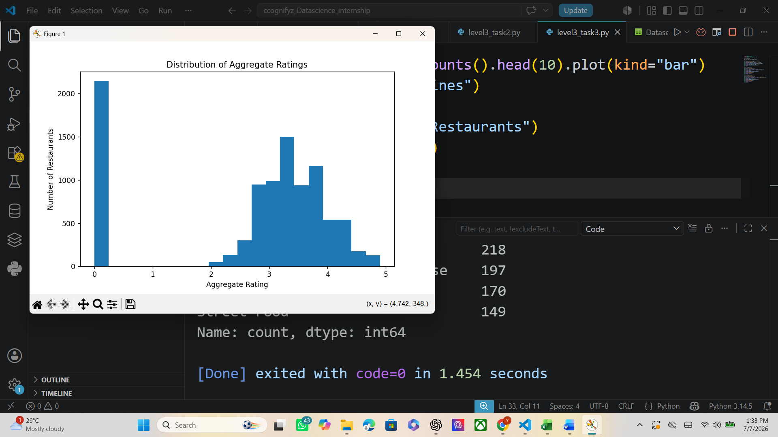
- Figure 9: Top Cities
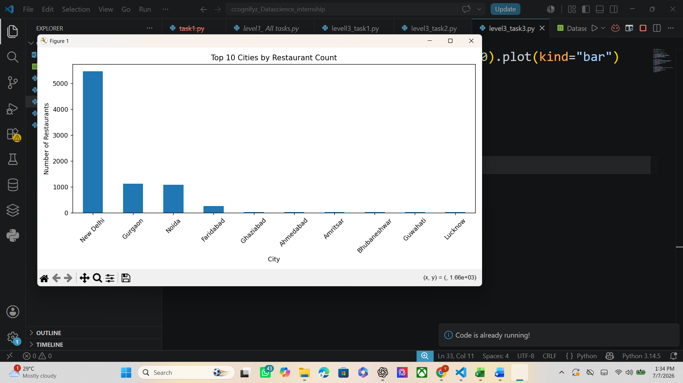

7.5 Observations
The visualizations clearly illustrated important characteristics of the dataset.
Most restaurants received ratings between 3.0 and 4.2. The city distribution showed that restaurant density is concentrated in a few major cities, while cuisine distribution highlighted the dominance of a limited number of cuisine categories.

8. Overall Results and Discussion
The Level 3 tasks successfully demonstrated the application of predictive analytics and visualization techniques.
Machine learning models were developed to estimate restaurant ratings, customer preference analysis revealed popular cuisines and voting patterns, and visualizations provided a clear understanding of the dataset.
Among the evaluated algorithms, Random Forest Regression delivered the highest prediction accuracy, making it the most effective model for this dataset.

9. Conclusion
The successful completion of Level 3 enhanced practical knowledge of machine learning, predictive modeling, customer preference analysis, and visualization techniques.
The project demonstrated how data preprocessing, model training, evaluation, and visualization can be combined to generate meaningful insights from real-world datasets.
Overall, this level strengthened practical skills in applying data science techniques to solve analytical problems and improved proficiency with Python-based machine learning libraries.

Acknowledgement
I would like to express my sincere gratitude to Cognifyz Technologies for providing the opportunity to participate in this Data Science Internship.
The Level 3 tasks provided valuable practical experience in predictive modeling, customer preference analysis, and data visualization using Python. This internship enhanced my technical skills and deepened my understanding of machine learning concepts and real-world data analysis.
I appreciate the structured learning experience and guidance offered throughout this internship, which has contributed significantly to my professional development in the field of data science.

